LWR Plus
Laubach Literacy Ontario

Task-Based Activities
for the LWR Series

Laubach Way to Reading (LWR) Book 1

LWR+ Task-Based Activities are aligned with the competencies and task groups within the Ontario Adult Literacy Curriculum Framework (OALCF) including level indicators and performance descriptors. They can also be used as stand-alone activities for learners at Level 1 who are not using Laubach Way to Reading skill books.



Acknowledgements

Researched and Written by: Robyn Cook-Ritchie
Project Managed by: Lana Faessler
Advisory Committee: Marilyn Davies
Stephanie Hobbs
Helen McLeod
Connie Morgan
Karen Morgan-Bowyer
Jo Mutch
Carol Risidore

Pilot Sites:

Task-based activities for LWR Book 1 were piloted by 25 practitioners and 44 learners from the following LBS agencies:

Hamilton Literacy Council
Literacy Council of Burlington
North Bay Literacy Council
The Literacy Group of Waterloo Region

Published by: Laubach Literacy Ontario
65 Noecker St., Room 8A
Waterloo, Ontario, N2J 2R6
Tel: (519) 743-3309 Fax: (519) 743-7520
Toll Free: 1-866 608-2574
Web: www.laubach-on.ca
© 2013

Evaluator: Sound Data Solutions, Owen Sound, Ontario

Laubach Literacy would like to thank the Ontario Trillium Foundation, which is an agency of the Government of Ontario, for funding this two-year project,
“Task-Based Activities for the LWR Series”.
Laubach Literacy Ontario Task-Based Activities for LWR Book #1
INTRODUCTION
LWR+ Task-Based Activities
Each of the task-based activities linked to the Laubach Way to Reading four-book series were developed using the criteria outlined by the Ontario Adult Literacy Curriculum Framework (OALCF).
The goal of this project was to create Canadian curriculum for International Adult Literacy Survey (IALS) Level 1 and 2 learners. Because the OALCF is linked to Canada’s Essential Skills and loosely tied to IALS levels, these resources will have applicability across Canada.
The task-based activities, while connected to each lesson in the Laubach Way to Reading series, can also be used as a stand-alone activity without the need for using the series. Each activity is also posted on our website, as a free download.
If you wish to purchase printed and bound LWR+ booklets, you can place your order in our online bookstore at http://www.laubach-on.ca/bookstore/llo-publications.
Please refer to the Task Based Activities Chart showing OALCF Competencies and Task Groups covered, as well as the Practitioner Guide on the following pages, for more detail.
Literacy practitioners have permission from the publisher to make copies of LWR+ for classroom and tutoring use.
Laubach Way to Reading (LWR) Series
Laubach Way to Reading is a basic reading and writing series developed primarily for adults with little or no reading ability. The series consists of four levels with student skill books, workbooks and correlated readers for learner use. The teacher’s edition for each level gives detailed instructions and lesson plans. Each lesson plan contains reading, writing, spelling and comprehension, as well as a “Meeting Individual Needs” section. The series is published by New Readers Press, a division of Pro-Literacy International. Laubach Literacy Ontario is a Canadian Distributor of New Readers Press material. For more information about the Laubach Literacy Bookstore, or to place orders, please visit http://www.laubach-on.ca/bookstore.
Member Support
This project was developed in response to member agency requests for Canadian resources that support Level 1 and 2 learners, and that can be easily understood and used by volunteer tutors.
Member Quotes
“These new task-based activities will be used by the staff and tutors to teach the students skills that will lead towards their actual goals.”
“Having Canadian material to use with our learners, that would provide our practitioners with a bank of materials referenced to the OALCF, would be extremely useful not only to our program, but to all of the literacy agencies in Ontario.”
TASK-BASED ACTIVITIES CHART FOR LWR BOOK # 1
OALCF Competencies and Task Groups
 | Competencies | Find and Use Information |  |  | Communicate Ideas and Information |  |  |  | Understand and Use Numbers |  |  |  | Page #
Lesson # | Activity  Description | Read continuous text | Interpret documents | Extract info from films, broadcasts, etc. | Interact with others | Write continuous text | Complete and Create Documents | Express oneself creatively | Manage money | Manage time | Use measures | Manage Data | Page #
 | Task Group # | A1 | A2 | A3 | B1 | B2 | B3 | B4 | C1 | C2 | C3 | C4
1 | Read a fish food label | .1 | .1 |  | .1 |  |  |  |  |  | .1 |  | 4
2 | Interpret a laundry label | .1 | .1 |  |  |  |  |  |  |  | .1 |  | 9
3 | Interpret washroom signs |  | .1 |  |  |  | .1a |  |  |  |  |  | 15
3 | Identify Poisonous Household Items |  | .1 |  |  |  | .1a |  |  |  |  |  | 20
4 | Describe each step in the pictorial diagram for cooking an egg |  | .1 |  | .1 | .1 |  |  |  |  |  |  | 25
5 | Read store directory to find the correct aisle |  | .1 |  |  |  |  |  |  |  |  |  | 31
5 | Create a shopping list |  |  |  |  |  |  |  |  |  |  |  | 37
6 | Write a thank you note |  |  |  |  | .1 |  |  |  |  |  |  | 42
7 | Complete a family tree |  |  |  |  |  | .1a |  |  |  |  |  | 47
8 | Read a dog tag |  | .1 |  | .1 |  |  |  |  |  |  |  | 52
9 | Find locations on a map |  | .2 |  |  |  |  |  |  |  |  |  | 57
10 | Read a recipe with fish and olive oil | .1 | .1 |  |  |  |  |  |  |  | .1 |  | 63
11 | Enter names, addresses and phone numbers in a personal phone book |  |  |  |  |  | .1a |  |  |  |  |  | 69
12 | Read a wedding invitation |  | .1 |  |  |  |  |  |  | .1 |  |  | 74
13 | This lesson introduces a correlated reader and how to read a table of contents.  No task-based activities have been added to this lesson.

PRACTITIONER GUIDE FOR LWR 1 TASK-BASED ACTIVITIES
The booklet provides practitioners with high interest activities that relate to the Laubach Way to Reading Series. The goal is to produce task-based activities that have a “connection” to the lessons. The connection may be related to vocabulary or topics in the material. The task-based activities are not necessarily related to the objectives of the lessons which are skill-based. Not all learners will be interested in all activities. They are simply meant to help practitioners and learners make connections between skills-based “in-class” learning and real life tasks they may encounter.
Learners who are working through LWR Skill Book 1 may find some of the activities challenging as they may not yet have the foundational skills to complete the tasks. Skills may need to be taught prior to having learners complete the activities. In many cases the skills needed to complete the task-based activities will exceed the current ability of some learners and they may need support from the practitioner.
Inputs are provided with the activities. The materials are meant to represent what a learner would encounter in the “real-world” as closely as possible while remaining as neutral as possible to ensure widespread applicability. It is always best practice to use real material when engaging learners in task-based activities. If you have access to local or “real” material that can be substituted – please do it! The more relevant the material to the learner’s world, the more engaged they will be with the activity.
Most activities include a “new words” section to help the practitioner and learner understand what words have not been covered in the skill books. Many of the words will be new for the learner. Practitioners can use a variety of methods to introduce the words to the learners. For example, flash cards or word matching exercises can be used to help introduce learners to new vocabulary. Keep in mind that the task-based activities are focused on the task itself as opposed to providing the foundational skills building. The practitioner needs to utilize his/her expertise to decide if a task-based activity is appropriate for a learner.
Each task-based activity has an overview chart in this guide. The overview chart includes the following sections:
• The name of the task-based activity
• The skill book and lesson number to which the task-based activity relates
• The Ontario Adult Literacy Curriculum Framework (OALCF) link
• The goal path(s) to which the task-based activity is most related
• The authentic material utilized in the activity
• Prior learning discussion and introduction to the activity
• New words discussion
• Activity instructions
• Learner self-assessment discussion
• Extension activities (in some cases)
Task-Based Activity: Read a fish food label
Laubach Connection: Laubach Way to Reading (LWR) Book 1, Lesson 1
OALCF Link
Relevant Goal Paths
Employment, Independence
Rationale: Learners on the Employment and Independence Paths will need to read labels for a variety of different reasons.
Task-Based Activity Description: The learner will read a brief text (product description) to locate specific details and interpret a very simple document (label) to locate specific details. The learner will participate in a brief exchange with the practitioner to answer the questions about the product description and label.
Competency, Task Group and Level Indicator
(See Assessment page for performance descriptors)
A: Find and Use Information
A1: Read continuous text
- A1.1: Read brief texts to locate specific details
A: Find and Use Information
A2: Interpret documents
- A2.1 Interpret simple documents to locate and connect information
B: Communicate Ideas and Information
B1: Interact with others
- B1.1 Participate in brief interactions to exchange information with one other person

Materials Required
- Pen or pencil and eraser
- Questions sheet with label

Overview
Activity Introduction
This task-based activity uses a fish food label and the text from a website describing the contents. In Lesson 1 the word “fish” is introduced. Discuss with the learner if they have ever had a pet fish before. Discuss the importance of understanding labels because labels provide you with information about products. Ask the learner if they have ever had any trouble reading a label before.

New words
Review the new words that are being introduced. Explain the meanings of the words to the learner. Not all new words are in the new word list. You may need to review additional words as the learner works though the activity.

Instructions
Have the learner fill in their name and the date. Have the learner complete the pre self-assessment. Read the product description over with the learner and then ask them the questions that follow. They can answer the questions orally. When they have completed the activity have the learner complete the post self-assessment. To increase the complexity of this task-based activity you can have the learner read the material independently and record their answers in writing. Adjust the descriptors as necessary. After the learner has completed the task-based activity complete the assessment section and review the results with the learner.

Extension activities
- Bring in a variety of different labels for the learner to interpret.
- Have the learner bring in labels from home that they are having difficulty understanding.

Task-Based Activity: Read a fish food label

Learner Name: ________________________________________ Date: ______________________________

Pre self -assessment

I need to improve my skills at reading labels:
- Yes
- No

 | New Words
algae  brown  completely  digest  eat | feed  food  ingredients  meal  oat | oil  rice  soybean  tropical  vitamin

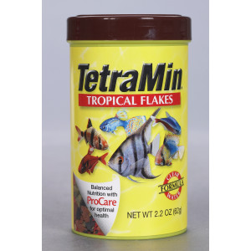
TetraMin is a fish food for all tropical fish.
This food is easy for fish to digest.
Ingredients: Fish meal, brown rice, shrimp meal, wheat gluten, oat meal, soybean meal, soybean oil, fish oil, algae meal, vitamin C.
Feed fish 2-3 times per day. Give fish as much as they will eat completely in three minutes.

Answer the following questions orally:

- What is the name of this fish food?

- What type of fish is this food for?

- How many different ingredients are in this fish food?

- How often should you feed your fish this food?

Post self-assessment

I think my skills have improved as a result of completing this activity.
- Yes
- No

Learner comments:
______________________________________________________________________________________________________
______________________________________________________________________________________________________
______________________________________________________________________________________________________

Assessment
Task-Based Activity: Read a fish food label
Learner Name: ________________________________________ Date: _________________________

Practitioner Name: _______________________________________

Performance Descriptors | Needs Work | Improving | Excellent
A1.1:
- Decodes words and makes meaning of sentences in a single text

- Reads short texts to locate a single piece of information
A2.1:
- Scans to locate specific details

- Locates specific details in simple documents, such as labels and signs
B1.1:
- Participates in short simple exchanges

- Repeats questions to confirm understanding

The learner needs to work on the following:

This task was successfully completed ______ This task needs to be tried again ______

Practitioner Comments:

Learner Comments:

Task-Based Activity: Interpret a laundry label on a karate uniform
Laubach Connection: Laubach Way to Reading (LWR) Book 1, Lesson 2
OALCF Link
Relevant Goal Paths
Employment, Independence
Rationale: Learners on the Employment and Independence Paths will need to interpret labels for a variety of different reasons.
Task-Based Activity Description: The learner will read a brief text (label description) to locate specific details and interpret a very simple document (label) to locate specific details. The learner will interpret temperature.
Competency, Task Group and Level Indicator
(See Assessment page for performance descriptors)
A: Find and Use Information
A1: Read continuous text
- A1.1: Read brief texts to locate specific details
A: Find and Use Information
A2: Interpret documents
- A2.1 Interpret very simple documents to locate specific details
C: Understand and Use Numbers
C3: Use Measures
- C3.1 Measure and make simple comparisons and calculations

Materials Required
- Pen or pencil and eraser
- Questions sheet with labels

Overview
Activity Introduction
This task-based activity uses a laundry symbol table and a laundry label from a karate uniform. In Lesson 2 the girl and the man are doing karate. When you do karate you usually wear a uniform. Discuss with the learner that you need to take care of the uniform. Most clothing that you buy has a label that tells you how to care for it. The label will usually have symbols and instructions.

New words
Review the new words that are being introduced. Explain the meanings of the words to the learner. Not all new words are in the new word list. You may need to review additional words as the learner works though the activity.

Instructions
Have the learner fill in their name and the date. Have the learner complete the pre self-assessment. Review the information in the laundry symbol table with the learner. Have the learner review the label that follows and answer the questions. When they have completed the activity have the learner complete the post self-assessment. After the learner has completed the task-based activity complete the assessment section and review the results with the learner.

Extension activities
- Bring in a variety of different laundry labels for the learner to interpret.
- Have the learner bring in laundry labels from home that they are having difficulty understanding.
- If you are working with a group of learners have them look at and interpret each other’s laundry tags on their coats, etc.

Task-Based Activity: Interpret a laundry label on a karate uniform

Learner Name: ________________________________________ Date: __________________________

Pre self-assessment

I need to improve my skills at understanding labels:
- Yes
- No

 | New Words
bleach  clean  clothes dryer  definition  dry clean | iron  item  laundry  symbol  temperature | uniform  wash  washing machine

Review the laundry symbols and definitions below.

Symbol | Definition
 | This is the symbol for washing in a washing machine. If there is a number in the symbol, it tells you what temperature you should wash the item at. If the symbol has an X through it you should not wash it in a washing machine.
 | This is the symbol for hand washing. If there is a number in the symbol, it tells you what temperature you should wash the item at.
 | This is the symbol for bleach. If the symbol has an X through it you should not use bleach.
 | This is the symbol for drying in a clothes dryer. If there is a number in the symbol, it tells you what temperature you should dry the item at. If the symbol has an X through it you should not use a clothes dryer.
 | This is the symbol for dry cleaning. If the symbol has an X through it you should not dry clean the item.

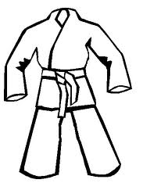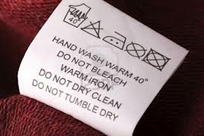

Read the label for the karate uniform and answer the questions.

- Can you wash the uniform in the washing machine? ___________

- What temperature should you wash the uniform at? ___________

- Can you dry clean the uniform? ___________

Post self-assessment

I think my skills have improved as a result of completing this activity.
- Yes
- No

Learner comments:
____________________________________________________________________________________________________
____________________________________________________________________________________________________
____________________________________________________________________________________________________

Assessment
Task-Based Activity: Interpret a laundry label on a karate uniform
Learner Name: ________________________________________ Date: _________________

Practitioner Name: _______________________________________

Performance Descriptors | Needs Work | Improving | Excellent
A1.1:
- Decodes words and makes meaning of sentences in a single text

- Reads short texts to locate a single piece of information
A2.1:
- Scans to locate specific details

- Interprets brief text and common symbols
C3.1:
- Recognizes values in number and word format

- Recognizes simple common shapes

The learner needs to work on the following:

This task was successfully completed ______ This task needs to be tried again ______

Practitioner Comments:

Learner Comments:

Task-Based Activity: Interpret washroom signs
Laubach Connection: Laubach Way to Reading (LWR) Book 1, Lesson 3
OALCF Link
Relevant Goal Paths
Independence
Rationale: Learners on the Independence Path will need to interpret washroom signs.
Task-Based Activity Description: The learner interprets very simple documents (signs) to locate specific details.
Competency, Task Group and Level Indicator
(See Assessment page for performance descriptors)
A: Find and Use Information
A2: Interpret documents
- A2.1 Interprets very simple documents to locate specific details
Materials Required
- Pen or pencil and eraser
- Questions sheet with label

Overview
Activity Introduction
This task-based activity uses a variety of different public bathroom signs. Some of the signs include vocabulary, and some are pictorial. Lesson 3 involves a campsite. Discuss where you encounter public washroom signs such as at a campground or a restaurant. Ask the learner if they have ever encountered a sign they weren’t sure of. Explain that different symbols or words can be used to represent men and women. For example, an image of a male deer and a female deer may be used to indicate a male and female washroom.

New words
Review the new words that are being introduced. Explain the meanings of the words to the learner. Not all new words are in the new word list. You may need to review additional words as the learner works though the activity.

Instructions
Have the learner fill in their name and the date. Have the learner complete the pre self-assessment. Have the learner look at each set of signs and circle the sign that indicates the men’s bathroom. When they have completed the activity have the learner complete the post self-assessment. After the learner has completed the task-based activity complete the assessment section and review the results with the learner.

Extension activities
- Bring in a variety of additional washroom signs for the learner to interpret.

Task-Based Activity: Interpret washroom signs

Learner Name: ________________________________________ Date: ____________________________

Pre self-assessment

I need to improve my skills at reading signs:
- Yes
- No

 | New Words
Guys | Dolls | Hers  His

For each set of signs, circle the sign for the men’s bathroom.

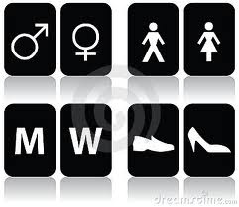 |  | 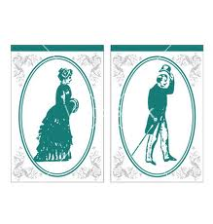
 |  | 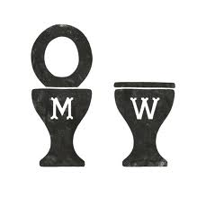
 | 
 |  | 

Post self-assessment

I think my skills have improved as a result of completing this activity.
- Yes
- No

Learner comments:
______________________________________________________________________________________________________
______________________________________________________________________________________________________
______________________________________________________________________________________________________

Assessment
Task-Based Activity: Interpret washroom signs
Learner Name: ________________________________________ Date: ____________________________

Practitioner Name: _______________________________________

Performance Descriptors | Needs Work | Improving | Excellent
A2.1:
- Interprets brief text and common symbols

The learner needs to work on the following:

This task was successfully completed ______ This task needs to be tried again ______

Practitioner Comments:

Learner Comments:

Task-Based Activity:
Identify Poisonous Household Items
Laubach Connection: Laubach Way to Reading (LWR) Book 1, Lesson 3
OALCF Link
Relevant Goal Paths
Employment, Independence
Rationale: Learners on the Employment and Independence Paths will need to read labels for a variety of different reasons.
Task-Based Activity Description: The learner will read and complete a simple checklist (common poisonous household items).
Competency, Task Group and Level Indicator
(See Assessment page for performance descriptors)
A: Find and Use Information
A2: Interpret documents
- A2.1 Interpret very simple documents to locate specific details
B: Communicate Ideas and Information
B3. Complete and create documents
- B3.1a The learner will make straightforward entries into a very simple document

Materials Required
- Pen or pencil and eraser
- Questions sheet with checklist

Overview
Activity Introduction
This task-based activity uses a checklist for common poisonous household items.
In Lesson 3 a snake is introduced. Many people are afraid of snakes as they think they are venomous or poisonous. Discuss with the learner how likely it is that they would encounter a venomous snake. Discuss how we encounter poisonous substances every day in our own homes. Explain that in this activity they will be using a checklist, which is an example of a document. Have the learner complete the pre self-assessment.

New words
Review the new words that are being introduced. Explain the meanings of the words to the learner. Not all new words are in the new word list. You may need to review additional words as the learner works though the activity.

Instructions
Have the learner fill in their name and the date. Have the learner complete the pre self-assessment. Review the safe home checklist with the learner. Make sure they understand all of the terms used. Have them complete the safe home checklist. Encourage them to set a short-term goal of using the safe home checklist to make sure they have stored all the poisonous products in their house safely. When they have completed the activity have the learner complete the post self-assessment. After the learner has completed the task-based activity complete the assessment section and review the results with the learner.

Extension activities
- Have the learners make a brief presentation on what items they had in their home.
- Use a dictionary to define unfamiliar words on the checklist or on products that they found in their home.

Task-Based Activity: Identify Poisonous Household Items

Learner Name: ________________________________________ Date: __________________

Pre self-assessment

I need to improve my skills at reading lists:
- Yes
- No

1. Review the Safe Homes Checklist for new words. Make a list of the new words and review them with your instructor.

2. Look at the Safe Homes Checklist. Check off all of the items you keep in your house. When you go home take the list and make sure you have them stored properly!

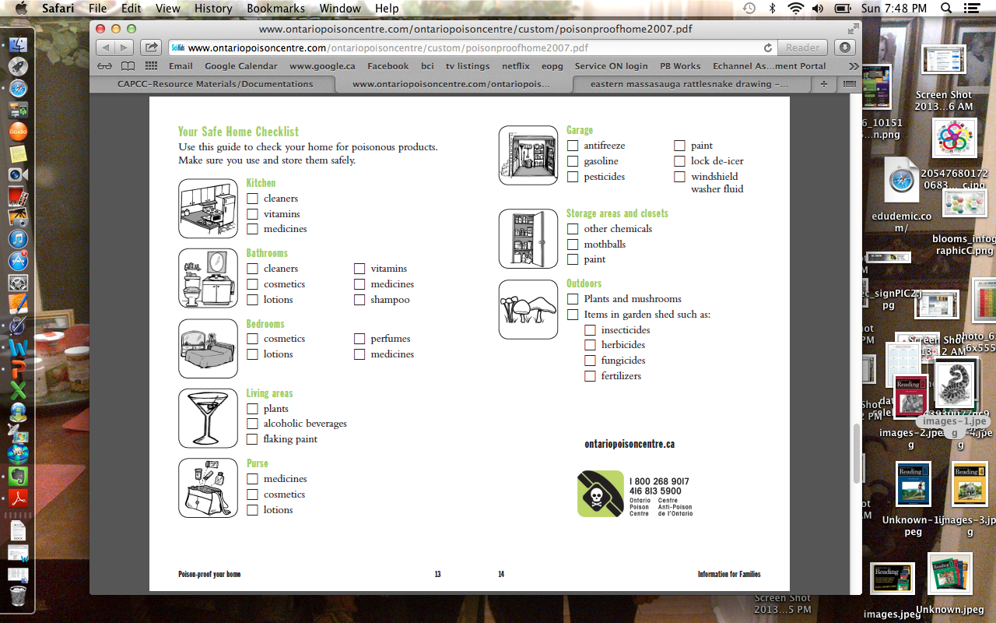

Post self-assessment

I think my skills have improved as a result of completing this activity.
- Yes
- No

Learner comments:
_________________________________________________________________________________________________________
_________________________________________________________________________________________________________
_________________________________________________________________________________________________________

Assessment
Task-Based Activity: Identify Poisonous Household Items
Learner Name: ________________________________________ Date: ___________________________

Practitioner Name: _______________________________________

Performance Descriptors | Needs Work | Improving | Excellent
A2.1:

- scans to locate specific details

- interprets brief text and common symbols

- identifies how lists are organized (e.g. sequential, chronological, alphabetical)

B3.1a:

- makes a direct match between what is requested and what is entered

- makes entries using familiar vocabulary

The learner needs to work on the following:

This task was successfully completed ______ This task needs to be tried again ______

Practitioner Comments:

Learner Comments:

Task-Based Activity: Describe each step in the pictorial diagram for cooking an egg.
Laubach Connection: Laubach Way to Reading (LWR) Book 1, Lesson 4
OALCF Link
Relevant Goal Paths
Employment, Independence
Rationale: Learners on the Employment and Independence Paths will need to read labels for a variety of different reasons.
Task-Based Activity Description: The learner will interpret a very simple document (5 step pictorial instructions) to locate details. The learner will write brief texts to convey simple ideas (describe the steps in writing) or participate in a brief exchange with one other person (describe the steps orally).
OALCF Competency, Task Group and Level Indicator
(See Assessment page for performance descriptors)
A: Find and Use Information
A2: Interpret documents
- A2.1 Interprets very simple documents to locate specific details
B: Communicate Ideas and Information
B2: Write continuous text
- B2.1 Writes brief texts to convey simple ideas and factual information.
Or

B1: Interact with Others
- B1.1 Participate in brief interactions to exchange information with one other person

Materials Required
- Pen or pencil and eraser
- Questions sheet with pictorial diagram

Overview
Activity Introduction
In this task-based activity a pictogram of how to cook an egg is used. In Lesson 4 the term “egg” is one of the new words introduced. Discuss the fact that pictorial instructions are often used in simple cooking or for assembly of things such as furniture. Ask the learner if they have ever bought a product with pictorial instructions. Have the learner complete the pre self-assessment.

New words
This activity is based on a pictorial diagram so no new words are introduced. However, the learner may identify new words as they complete the activity. Explain the meanings of the words to the learner.

Instructions
Have the learner fill in their name and the date. Have the learner complete the pre self-assessment. Discuss the steps depicted in the pictogram to cook an egg. Have the learner write a point form description for each step. If the learner is not comfortable writing a description the activity can be done orally. After the learner has completed the task-based activity complete the assessment section and review the results with the learner.

Extension activities
- Have the learner create a pictorial diagram for a simple task

Task-Based Activity: Describe each step in the pictorial diagram for cooking an egg.

Learner Name: ________________________________________ Date: ____________________________

Pre self- assessment

I need to improve my skills at understanding diagrams:
- Yes
- No
Look at the pictorial instructions to cook a boiled egg. There are five steps. Describe each step in the process. You can use point form.

Step | Pictorial Instruction | Description
1 | 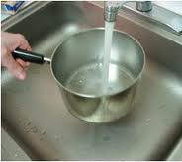
2 | 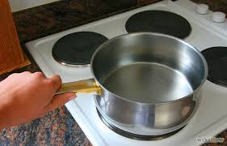
3 | 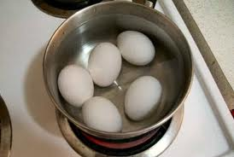
4 | 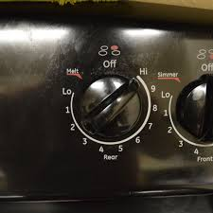
5 | 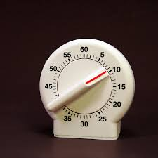

Post self-assessment

I think my skills have improved as a result of completing this activity.
- Yes
- No

Learner comments:
_________________________________________________________________________________________________
_________________________________________________________________________________________________
_________________________________________________________________________________________________

Assessment
Task-Based Activity: Describe each step in the pictorial diagram for cooking an egg.
Learner Name: ________________________________________ Date: ____________________________

Practitioner Name: _______________________________________

Performance Descriptors | Needs Work | Improving | Excellent
A2.1:
- locates specific details in simple documents, such as labels and signs
- identifies how lists are organized (e.g. sequential, chronological, alphabetical)

B2.1:
- writes simple texts to request, remind or inform
- conveys simple ideas and factual information
- demonstrates a limited understanding of sequence
- uses sentence structure, upper and lower case and basic punctuation
- uses highly familiar vocabulary

The learner needs to work on the following:

This task was successfully completed ______ This task needs to be tried again ______

Practitioner Comments

Learner Comments:

Task-Based Activity:
Use the store directory to find the correct aisle
Laubach Connection: Laubach Way to Reading (LWR) Book 1, Lesson 5
OALCF Link
Relevant Goal Paths
Employment, Independence
Rationale: Learners on the Employment and Independence Paths will need to read directories for a variety of different reasons.
Task-Based Activity Description: The learner will read a brief chart (store directory) to locate specific details (location of items).
OALCF Competency, Task Group and Level Indicator
(See Assessment page for performance descriptors)
A: Find and Use Information
A2: Interpret documents
- A2.1: Interpret very simple documents to locate specific details
Materials Required
- Pen or pencil and eraser
- Questions sheet with directory

Overview
Activity Introduction
This task-based activity uses a directory for a department store. In Lesson 5 the learner is introduced to a shop and some of the items that you can purchase in a shop. Discuss with the learner if they have ever been to a department store to make a purchase. Ask them if they have ever tried to figure out where something is in a store using a directory. Discuss the fact that store directories are usually organized alphabetically. Point out that not every item will be listed on a directory.

New words
Review the new words that are being introduced. Explain the meanings of the words to the learner. Not all new words are in the new word list. You may need to review additional words as the learner works though the activity.

Instructions
Have the learner fill in their name and the date. Have the learner complete the pre self-assessment. Have the learner look at the store directory to determine where they are most likely to find the items on their shopping list. When they have completed the activity have the learner complete the post self-assessment. After the learner has completed the task-based activity complete the assessment section and review the results with the learner.

Extension activities
- Bring in a variety of different directories for the learner to interpret.
- Use the telephone book to help the learner understand alphabetical order.

Task-Based Activity: Use the store directory to find the correct aisle

Learner Name: ________________________________________ Date: ____________________________

Pre self-assessment

I need to improve my skills at reading directories:
- Yes
- No

 | New Words
art  automotive  baby  care  cleaning  clothing  cookware | department  electronics  foot ware  furniture  hair  hardware  needs | paper  products  school  sewing  store  supplies

Bullseye Department Store
Directory

 | Aisle |  | Aisle
A  Art supplies  Automotive | 8  5 | F  Foot ware  Furniture | 4  6
B  Baby needs  Beauty needs | 1  1 | H  Hair care  Hardware | 1  7
C  Cleaning Supplies  Clothing  Cookware | 2  4  2 | P  Paper products | 2
E  Electronics | 3 | S  School supplies  Sewing | 8  4

You need to buy some items at the Bullseye Department Store:
- A new pan
- A dish to cook in
- A zipper to fix your pants

What aisle would you find the zippers in? __________

What aisle would you find a pan in? ________

What aisle would you find a dish in? ________

Post self-assessment

I think my skills have improved as a result of completing this activity.
- Yes
- No

Learner comments:
_________________________________________________________________________________________________
_________________________________________________________________________________________________
_________________________________________________________________________________________________

Assessment
Task-Based Activity: Use the store directory to find the correct aisle
Learner Name: ________________________________________ Date: ____________________________

Practitioner Name: _______________________________________

Performance Descriptors | Needs Work | Improving | Excellent
A2:
- scans to locate specific details

- interprets brief text and common symbols

- identifies how lists are organized (e.g. sequential, chronological, alphabetical)

The learner needs to work on the following:

This task was successfully completed ______ This task needs to be tried again ______

Practitioner Comments:

Learner Comments:

Task-Based Activity: Create a shopping list
Laubach Connection: Laubach Way to Reading (LWR) Book 1, Lesson 5
OALCF Link
Relevant Goal Paths
Apprenticeship, Employment, Independence, Postsecondary, Secondary School Credit
Rationale: Learners on all of the paths will need to create shopping lists for a variety of different reasons.
Task-Based Activity Description: The learner will create a short shopping list of ten supplies from a dollar store that might be needed for school.
OALCF Competency, Task Group and Level Indicator
(See Assessment page for performance descriptors)
B: Communicate Ideas and Information
B3: Create and complete documents
- B3.1b: Create very simple documents to display and organize a limited amount of information

Materials Required
- Pen or pencil and eraser
- Questions sheet with shopping list template

Overview
Activity Introduction
This task-based activity uses a blank shopping list template. In Lesson 5 the learner is introduced to a shop and some of the items that you can purchase in a shop. Discuss whether the learner has ever shopped at a dollar store. Have they ever purchased school supplies at a dollar store for themselves or a child? Discuss how shopping lists can help you stay organized and keep you from making impulse purchases.

New words
This activity doesn’t introduce new words. However, the learner may need some assistance if they use new words to complete the activity.

Instructions
Have the learner fill in their name and the date. Have the learner complete the pre self-assessment. Have the learner create a shopping list for ten school supply items they may be able to purchase at a dollar store. After the learner has completed the task-based activity complete the assessment section and review the results with the learner.

Extension activities
- Have the learner use the template to create shopping lists for a variety of different purposes.
- Have the learner bring in flyers from home for places they shop and use the template to create lists.

Task-Based Activity: Create a shopping list

Learner Name: ________________________________________ Date: ____________________________

Pre self-assessment

I need to improve my skills at making lists that help me stay organized:
- Yes
- No

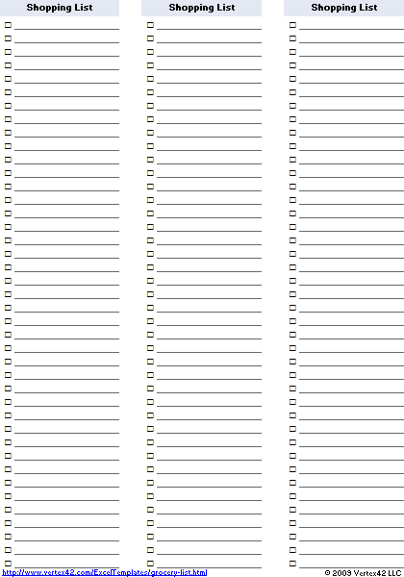

Post self-assessment

I think my skills have improved as a result of completing this activity.
- Yes
- No

Learner comments:
_________________________________________________________________________________________________
_________________________________________________________________________________________________
_________________________________________________________________________________________________

Assessment
Task-Based Activity: Create a shopping list
Learner Name: ________________________________________ Date: ____________________________

Practitioner Name: _______________________________________

Performance Descriptors | Needs Work | Improving | Excellent
B3:
- follows conventions to display information in lists, labels, simple forms, signs (e.g. images support the message, text is legible)

- organizes lists to suit purpose (e.g. chronologically, alphabetically, numerically, sequentially)

- includes titles where required

The learner needs to work on the following:

This task was successfully completed ______ This task needs to be tried again ______

Practitioner Comments:

Learner Comments:

Task-Based Activity: Write a thank you note
Laubach Connection: Laubach Way to Reading (LWR) Book 1, Lesson 6
OALCF Link
Relevant Goal Paths
Employment, Independence
Rationale: Learners on the Employment and Independence Paths will need to write thank you notes for a variety of different reasons.
Task-Based Activity Description: The learner will write a brief text (thank you note) to convey simple ideas.
OALCF Competency, Task Group and Level Indicator
(See Assessment page for performance descriptors)
B: Communicate Ideas and Information
B2: Write continuous text
- B2.1 Write brief texts to convey simple ideas and factual information

Materials Required
- Pen or pencil and eraser
- Questions sheet with blank thank you note template

Overview
Activity Introduction
This task-based activity uses a blank thank you note template. In Lesson 6 the term “thank-you” is introduced. Discuss the use of thank you cards as a way to show gratitude. Ask if they have ever given someone a thank you card or note with a personal message.

New words
Review the new words that are being introduced. Explain the meanings of the words to the learner. Not all new words are in the new word list. You may need to review additional words as the learner works though the activity.

Instructions
Have the learner fill in their name and the date. Have the learner complete the pre self-assessment. Have the learner think of someone they would like to thank and complete the brief thank you note. When they have completed the activity have the learner complete the post self-assessment. After the learner has completed the task-based activity complete the assessment section and review the results with the learner.

Extension activities
- Use the template and have the learner write a variety of thank you notes to different people.

Task-Based Activity: Write a thank you note

Learner Name: ________________________________________ Date: ____________________________

Pre self-assessment

I need to improve my writing skills:
- Yes
- No

 | New Words
dear | from

Think of someone who you would like to thank. Write a brief note to that person telling them what you would like to thank them for. When you are finished, make sure you sign your name.

Dear __________________________________,

Thank you for ____________________________________________

_____________________________________________________________________

_____________________________________________________________________

_____________________________________________________________________

_____________________________________________________________________

From,

________________________________________

Post self-assessment

I think my skills have improved as a result of completing this activity.
- Yes
- No

Learner comments:
_________________________________________________________________________________________________
_________________________________________________________________________________________________
_________________________________________________________________________________________________

Assessment
Task-Based Activity: Write a thank you note
Learner Name: ________________________________________ Date: ____________________________

Practitioner Name: _______________________________________

Performance Descriptors | Needs Work | Improving | Excellent
B2:
- writes simple texts to request, remind or inform

- conveys simple ideas and factual information

- demonstrates a limited understanding of sequence

- uses sentence structure, upper and lower case and basic punctuation

- uses highly familiar vocabulary

The learner needs to work on the following:

This task was successfully completed ______ This task needs to be tried again ______

Practitioner Comments:

Learner Comments:

Task-Based Activity: Complete a family tree
Laubach Connection: Laubach Way to Reading (LWR) Book 1, Lesson 7
OALCF Link
Relevant Goal Paths
Employment, Independence
Rationale: Learners on the Independence Path may want to create a family tree.
Task-Based Activity Description: The learner will make straightforward entries (family member names) to complete a simple document (family tree template).
OALCF Competency, Task Group and Level Indicator
(See Assessment page for performance descriptors)
B: Communicate Ideas and Information
B3. Complete and create documents
- B3.1a Make straightforward entries into very simple documents

Materials Required
- Pen or pencil and eraser
- Questions sheet with family tree template

Overview
Activity Introduction
A simple family tree template is used in this task-based activity. You can substitute with a similar template or have the learners create a family tree. In Lesson 7 a family is spending a day at the river. Discuss the relationships between the people at the river. Discuss whether the learner has ever created a family tree before. Ask the learner if they have any siblings.

New words
Review the new words that are being introduced. Explain the meanings of the words to the learner. Not all new words are in the new word list. You may need to review additional words as the learner works though the activity.

Instructions
Have the learner fill in their name and the date. Have the learner complete the pre self-assessment. Review the different sections on the family tree template with the learner. Show them where to put their name. Explain that they may not be able to fill out all of the spots; it will depend on their family. Have them complete the rest of the family tree. After the learner has completed the task-based activity complete the assessment section and review the results with the learner.

Extension activities
- Have the learner create a family tree from scratch instead of using the template provided. This could involve the task group “express oneself creatively”.

Task-Based Activity: Complete a family tree

Learner Name: ________________________________________ Date: ____________________________

Pre self-assessment

I need to improve my skills at using and understanding documents:
- Yes
- No

 | New Words
brother  sister | mother  father | grandmother  grandfather  relatives

Complete the simple family tree by filling in the names of your relatives. Start by writing your own name at the bottom in the spot that says “me”.

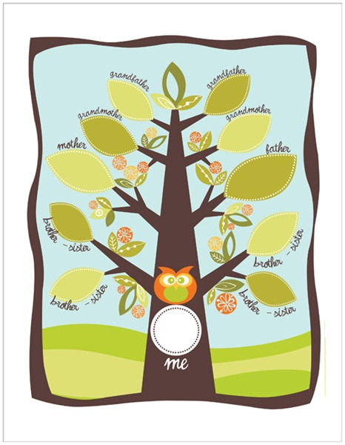

Post self-assessment

I think my skills have improved as a result of completing this activity.
- Yes
- No

Learner comments:
_________________________________________________________________________________________________
_________________________________________________________________________________________________
________________________________________________________________________________________________

Assessment
Task-Based Activity: Complete a family tree
Learner Name: ________________________________________ Date: ____________________________

Practitioner Name: _______________________________________

Performance Descriptors | Needs Work | Improving | Excellent
B3:
- makes a direct match between what is requested and what is entered

- makes entries using familiar vocabulary

The learner needs to work on the following:

This task was successfully completed ______ This task needs to be tried again ______

Practitioner Comments:

Learner Comments:

Task-Based Activity: Read a dog tag
Laubach Connection: Laubach Way to Reading (LWR) Book 1, Lesson 8
OALCF Link
Relevant Goal Paths
Independence
Rationale: Learners on the Independence Path may need to read a tag on a pet.
Task-Based Activity Description: The learner will interpret a very simple document (dog tag) to locate specific details.
OALCF Competency, Task Group and Level Indicator
(See Assessment page for performance descriptors)
A: Find and Use Information
A2: Interpret documents
- A2.1 Interpret very simple documents to locate specific details
B: Communicate Ideas and Information
B1: Interact with others
- B1.1 Participate in brief interactions to exchange information with one other person
Materials Required
- Pen or pencil and eraser
- Questions sheet with dog tag

Overview
Activity Introduction
This task-based activity uses a dog tag. In Lesson 8 the learner is introduced to a “pup”. Discuss with the learner that pup is a short form of the word puppy. Ask the learner if they have ever had a pet dog or found a lost dog. Discuss why dogs have to be licensed and wear dog tags. Explain that a dog tag is a type of simple document that we have to interpret.

New words
Review the new words that are being introduced. Explain the meanings of the words to the learner. Not all new words are in the new word list. You may need to review additional words as the learner works though the activity.

Instructions
Have the learner fill in their name and the date. Have the learner complete the pre self-assessment. Have the learner review the dog tag and answer the questions that follow orally. After the learner has completed the task-based activity complete the assessment section and review the results with the learner.

Extension activities
- Create a variety of different tags for the learner to interpret.
- If the learner has a dog, ask them to copy down the information on the tag (if the dog is licensed). If the dog is not licensed do an Internet search with the learner to learn more about the requirements of licensing where they live.
- Do the same activity with a medic alert tag if you have one available.

Task-Based Activity: Read a dog tag

Learner Name: ________________________________________ Date: ____________________________

Pre self-assessment

I need to improve my skills at reading documents:
- Yes
- No

 | New Words
call  licence | lost  name | neighbourhood  please

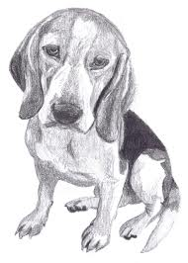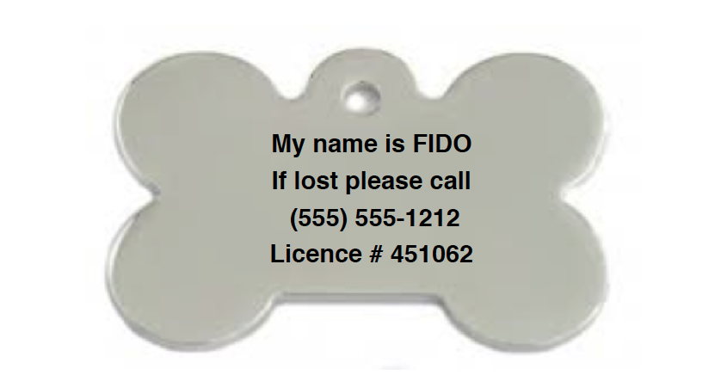

Look at the dog tag and answer the following questions orally:

- What is the dog’s name?

- If you found this dog in your neighbourhood what phone number would you call?

- What is the number of the licence?

Post self-assessment

I think my skills have improved as a result of completing this activity.
- Yes
- No

Learner comments:
_________________________________________________________________________________________________
_________________________________________________________________________________________________
_________________________________________________________________________________________________

Assessment
Task-Based Activity: Read a dog tag
Learner Name: ________________________________________ Date: ____________________________

Practitioner Name: _______________________________________

Performance Descriptors | Needs Work | Improving | Excellent
A2:
- scans to locate information

- interprets brief text and common symbols

- locates specific details in simple documents, such as labels and signs

B1:
- Participates in short simple exchanges

- Repeats questions to confirm understanding

The learner needs to work on the following:

This task was successfully completed ______ This task needs to be tried again ______

Practitioner Comments:

Learner Comments:

Task-Based Activity: Find locations on a map
Laubach Connection: Laubach Way to Reading (LWR) Book 1, Lesson 9
OALCF Link
Relevant Goal Paths
Employment, Independence
Rationale: Learners on the Employment and Independence Paths will need to read labels for a variety of different reasons.
Task-Based Activity Description: The learner will read a simple document (street map from the internet) to locate and connect information.
OALCF Competency, Task Group and Level Indicator
(See Assessment page for performance descriptors)
A: Find and Use Information
A2: Interpret documents
- A2.2 Interpret simple documents to locate and connect information
Materials Required
- Pen or pencil and eraser
- Questions sheet with map (Note: Activity will work better if printed in colour).

Overview
Activity Introduction
This task-based activity uses a Google map from the Internet that includes “York Street”. In Lesson 9 the learner is introduced to Uncle Ted’s Pet Shop. Discuss with the learner if they have ever read a city map before to locate a store. Discuss if the learner has ever looked at Google maps online. Ask the learner if they have ever had any trouble reading a map before.

New words
Review the new words that are being introduced. Explain the meanings of the words to the learner. Not all new words are in the new word list. You may need to review additional words as the learner works though the activity.

Instructions
Have the learner fill in their name and the date. Have the learner complete the pre self-assessment. Review the map with the learner. Explain that the yellow and white lines represent streets, the green spaces represent parks, and the blue represents water. Have the learner find the various locations requested on the map. To make activity more authentic search for a map of London, Ontario online and use the same section of the map for the learner to complete the activity. Adjust the descriptors as necessary. After the learner has completed the task-based activity complete the assessment section and review the results with the learner.

Extension activities
- Use a local street map to locate stores and the literacy agency.
- Search for your local area on Google maps and locate places relevant to the learner.
- Have the learner give verbal directions between two locations on the map.

Task-Based Activity:

Learner Name: ________________________________________ Date: ____________________________

Pre self-assessment

I need to improve my skills at reading maps:
- Yes
- No

 | New Words
located  circle  corner | star  map  mark | park  walk

Ted’s Pet Shop is located at 3574 York Street.

- Find York Street on the map.

- The pet shop is located at the corner of Wellington Street and York Street. Mark the corner of Wellington Street and York Street with a star.

- Ted has a dog. He likes to walk his dog at Belvedere Park. Circle Belvedere Park on the map.

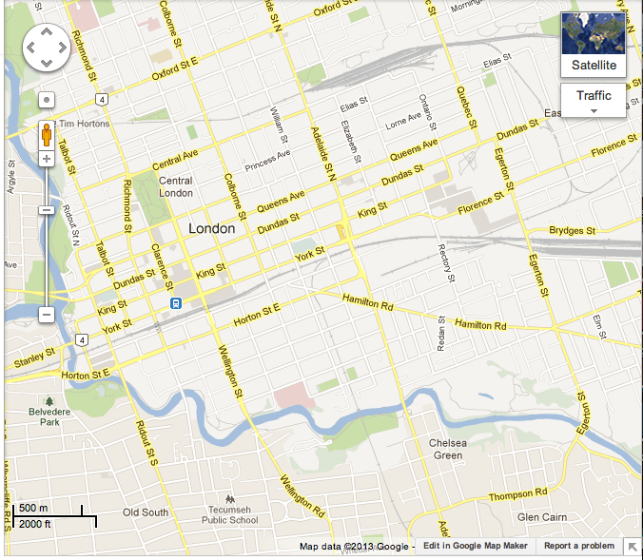

Post self-assessment

I think my skills have improved as a result of completing this activity.
- Yes
- No

Learner comments:
_________________________________________________________________________________________________
_________________________________________________________________________________________________
_________________________________________________________________________________________________

Assessment
Task-Based Activity:
Learner Name: ________________________________________ Date: ____________________________

Practitioner Name: _______________________________________

Performance Descriptors | Needs Work | Improving | Excellent
A2:
- performs limited searches using one or two search criteria

- locates information in simple graphs and maps

- uses layout to locate information

- makes connections between parts of documents

The learner needs to work on the following:

This task was successfully completed ______ This task needs to be tried again ______

Practitioner Comments:

Learner Comments:

Task-Based Activity:
Read a recipe with fish and olive oil
Laubach Connection: Laubach Way to Reading (LWR) Book 1, Lesson 10
OALCF Link
Relevant Goal Paths
Employment, Independence
Rationale: Learners on the Employment and Independence Paths may need to read a recipe for a variety of different reasons.
Task-Based Activity Description: The learner will read a brief text (preparation instructions) to locate details and interpret a very simple document (ingredients list) to locate details.
OALCF Competency, Task Group and Level Indicator
(See Assessment page for performance descriptors)
A: Find and Use Information
A1: Read continuous text
- A1.1: Read brief texts to locate specific details
A: Find and Use Information
A2: Interpret documents
- A2.1 Interpret very simple documents to locate specific details
C: Understand and Use Numbers
C3: Use Measures
- C3.1 Measure and make simple comparisons and calculations
Materials Required
- Pen or pencil and eraser
- Questions sheet with recipe

Overview
Activity Introduction
This task-based activity uses a recipe to prepare fish. Lesson 10 is about a fishing trip. Discuss with the learner whether they have ever been fishing. Ask the learner if they have ever eaten or cooked fresh fish.

New words
Review the new words that are being introduced. Explain the meanings of the words to the learner. Not all new words are in the new word list. Measurement terms are also introduced in this activity. Review the measurement terms with the learners and explain the meanings. You may need to review additional words as the learner works though the activity.

Instructions
Have the learner fill in their name and the date. Have the learner complete the pre self-assessment. Have the learner review the recipe and answer the questions that follow. After the learner has completed the task-based activity complete the assessment section and review the results with the learner.

Extension activities
- If you have facilities, actually cook.
- Have the learner bring in recipes from home that they are interested in and are having difficulty understanding.

Task-Based Activity: Read a recipe with fish and olive oil

Learner Name: ________________________________________ Date: ____________________________

Pre self-assessment

I need to improve my skills at reading recipes:
- Yes
- No

 | New Words
caper  fillet  flake  fresh  ingredients  lemon | minced  opaque  oil  oregano  pickerel  preparation | recipe  salt  season  skin  watercress  wedge

 | New Measurements
bunch  cup | tbsp  tsp | ml  kg

Recipe: Fresh Fish and Olive Oil
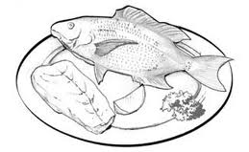

Ingredients
- 1/3 cup (75 mL) extra virgin olive oil
- 3 lb (1.4 kg) pickerel fillets, skin on
- 1 tbsp (15 mL) minced fresh oregano
- 1 tsp (5 mL) sea salt
- 2 tbsp (30 mL) capers
- 1 lemon, cut into wedges
- 1 bunch watercress

Preparation
Remove half of the oil and set aside. Brush remaining oil over both sides of fish fillets. Season tops with oregano, salt and pepper. Place, skin side down, on greased grill over medium heat; close lid and grill, without turning, until fish is opaque and flakes easily when tested, about 10 minutes. Transfer to warmed platter. Drizzle with reserved oil; sprinkle with capers. Surround with lemon and watercress.
Source: Canadian Living Magazine: August 2006; Get Grilling: Summer 2007

Answer the following questions:

- How much olive oil does this recipe use? __________________________________

- How many lemons do you need to make this recipe? ___________________

- What seasonings do you use in this recipe? ______________________ , _____________________ , __________________________

- What type of fish is used in this recipe? __________________________________

Post self-assessment

I think my skills have improved as a result of completing this activity.
- Yes
- No

Learner comments:
_________________________________________________________________________________________________
_________________________________________________________________________________________________
_________________________________________________________________________________________________

Assessment
Task-Based Activity: Read a recipe with fish and olive oil
Learner Name: ________________________________________ Date: ____________________________

Practitioner Name: _______________________________________

Performance Descriptors | Needs Work | Improving | Excellent
A1:
- reads short texts to locate a single piece of information
- decodes words and makes meaning of sentences in a single text
- follow simple, straightforward instructional texts
A2:
- scans to locate specific details
- interprets brief text and common symbols
- locates specific details in simple documents, such as labels and signs
C3:
- recognizes values in number and word format
- measures distance, length, width, height, weight, liquid volume, angles and temperature

The learner needs to work on the following:

This task was successfully completed ______ This task needs to be tried again ______

Practitioner Comments:

Learner Comments:

Task-Based Activity: Enter names, addresses and phone numbers in a personal phone book
Laubach Connection: Laubach Way to Reading (LWR) Book 1, Lesson 11
OALCF Link
Relevant Goal Paths
Employment, Independence
Rationale: Learners on the Employment and Independence Paths will need to keep track of phone numbers and addresses for a variety of different reasons.
Task-Based Activity Description: The learner will make straightforward entries (addresses from lesson 11) into very simple documents (address book).
OALCF Competency, Task Group and Level Indicator
(See Assessment page for performance descriptors)
B: Communicate Ideas and Information
B3: Complete and create documents
- B3.1a Make straightforward entries into very simple documents

Materials Required
- Pen or pencil and eraser
- Questions sheet with same phone and address book page

Overview
Activity Introduction
This task-based activity uses a sample phone and address book page. In Lesson 11 several names, addresses and phone numbers are introduced. Ask the learner if they keep a personal phone and address book. Discuss the fact that many people keep these electronically but the concept is still the same. Explain that this is an example of a very simple document.

New words
Review the new words that are being introduced. Explain the meanings of the words to the learner. Not all new words are in the new word list. You may need to review additional words as the learner works though the activity.

Instructions
Have the learner fill in their name and the date. Have the learner complete the pre self-assessment. Have the learner enter the names, addresses and phone numbers in the personal phone book page. After the learner has completed the task-based activity complete the assessment section and review the results with the learner.

Extension activities
- Complete the activity using authentic names and addresses from the phone book.
- Use the Internet 411 or Canada Post service to look up addresses to add.
- Have the learners complete a self- addressed envelope.

Task-Based Activity: Enter names, addresses and phone numbers in a personal phone book

Learner Name: ________________________________________ Date: ____________________________

Pre self-assessment

I need to improve my skills at completing documents
- Yes
- No

 | New Words
name | address

1. Enter the following names, addresses and phone numbers in the personal phone book on the next page.

Bob Hill
19 Valley Street
Indian Valley
234-9169

Cal Bird
9 Valley Street
Indian Valley
234-8571

Mrs. Oliver
426 River Street
London
446-5555

2. Add your own name and address and phone number.

Name _________________________________________  Address _____________________________________  __________________________________________________  __________________________________________________  Phone ( ) ________ - _____________________ | Name _________________________________________  Address _____________________________________  __________________________________________________  __________________________________________________  Phone ( ) ________ - _____________________
Name _________________________________________  Address _____________________________________  __________________________________________________  __________________________________________________  Phone ( ) ________ - _____________________ | Name _________________________________________  Address _____________________________________  __________________________________________________  __________________________________________________  Phone ( ) ________ - _____________________
Name _________________________________________  Address _____________________________________  __________________________________________________  __________________________________________________  Phone ( ) ________ - _____________________ | Name _________________________________________  Address _____________________________________  __________________________________________________  __________________________________________________  Phone ( ) ________ - _____________________

Post self-assessment

I think my skills have improved as a result of completing this activity.
- Yes
- No

Learner comments:
_________________________________________________________________________________________________
_________________________________________________________________________________________________
________________________________________________________________________________________________

Assessment
Task-Based Activity: Enter names, addresses and phone numbers in a personal phone book
Learner Name: ________________________________________ Date: ____________________________

Practitioner Name: _______________________________________

Performance Descriptors | Needs Work | Improving | Excellent
B3:
- makes a direct match between what is requested and what is entered

- makes entries using familiar vocabulary

The learner needs to work on the following:

This task was successfully completed ______ This task needs to be tried again ______

Practitioner Comments:

Learner Comments:

Task-Based Activity: Read a wedding invitation
Laubach Connection: Laubach Way to Reading (LWR) Book 1, Lesson 12
OALCF Link
Relevant Goal Paths
Independence
Rationale: Learners on the Independence Paths will need to read invitations for a variety of different reasons.
Task-Based Activity Description: The learner will interpret a very simple document (wedding invitation) to locate specific details. The learner will interpret time using numbers and number words.
OALCF Competency, Task Group and Level Indicator
(See Assessment page for performance descriptors)
A: Find and Use Information
A2: Interpret documents
- A2.1 Interpret very simple documents to locate specific details
C: Understand and Use Numbers
C2: Manage time
- C2.1 Measure time and make simple comparisons and calculations

Materials Required
- Pen or pencil and eraser
- Questions sheet with invitation

Overview
Activity Introduction
This task-based activity uses a wedding invitation. In Lesson 12 number words are introduced. Discuss with the learner where they might encounter number words. For example, on store signs, on an invitation, when they are writing a cheque.

New words
Review the new words that are being introduced. Explain the meanings of the words to the learner. Not all new words are in the new word list. You may need to review additional words as the learner works though the activity.

Instructions
Have the learner fill in their name and the date. Have the learner complete the pre self-assessment. Have the learner read the invitation and answer the questions that follow. Make sure they understand they are answering using numbers, not number words. After the learner has completed the task-based activity complete the assessment section and review the results with the learner.

Extension activities
- Bring in a variety of different invitations for the learner to interpret.
- Have the learners create an invitation.

Task-Based Activity: Read a wedding invitation

Learner Name: ________________________________________ Date: ____________________________

Pre self-assessment

I need to improve my skills at reading documents:
- Yes
- No

 | New Words
afternoon  exchange | reception  Saturday  thousand | vows  wedding

Look at the following wedding invitation and answer the questions. Answer using numbers.
Please join

Bethany & William
as they exchange wedding vows
Saturday, September 22nd
two thousand and twelve

Reception to follow at 6 o’clock
Main Building, Chippewa Park

- What year are Bethany and William exchanging wedding vows? ____________________

- What time is the wedding? ________________________

- What time is the reception? _______________________

Post self-assessment

I think my skills have improved as a result of completing this activity.
- Yes
- No

Learner comments:
_________________________________________________________________________________________________
_________________________________________________________________________________________________
________________________________________________________________________________________________

Assessment
Task-Based Activity: Read a wedding invitation
Learner Name: ________________________________________ Date: ____________________________

Practitioner Name: _______________________________________

Performance Descriptors | Needs Work | Improving | Excellent
A2:
- scans to locate specific details

- interprets brief text and common symbols

- locates specific details in simple documents, such as labels and signs

C2:
- recognizes values in number and word format

- understands and uses common date formats

- represents dates and times using standard conventions

The learner needs to work on the following:

This task was successfully completed ______ This task needs to be tried again ______

Practitioner Comments:

Learner Comments:

