Task-Based Activity: Interpret a small town map
Laubach Connection: Laubach Way to Reading (LWR) Book 4, Lesson 9
OALCF Link
Relevant Goal Paths
Apprenticeship, Employment, Independence, Postsecondary, Secondary School Credit
Rationale: Learners on the Apprenticeship, Employment, Independence, Postsecondary and Secondary School Credit Paths will need to read maps for a variety of different reasons.

Task-Based Activity Description: The learner will interpret a simple document (street map) to locate and connect information (A2.2).
Competency, Task Group and Level Indicators
(See Assessment page for performance descriptors)
A: Find and Use Information
A2: Interpret documents
- A2.2: Interpret simple documents to locate and connect information

Materials Required
- Pen or pencil and eraser
- Question sheets

Overview
Activity Introduction
In lesson nine, a street map is introduced. This task uses a town street map with a legend. The learner will examine the map and use it to answer the questions.

New words
Determine any new words that you think are being introduced in the activity and review those words with the learner.

Instructions
- Have the learner fill in their name and the date.
- Have the learner complete the pre self-assessment.
- Have the learner complete the task-based activity.
- After completing the activity, have the learner complete the post self-assessment.
- After the learner has completed the task-based activity, complete the assessment section and review the results with the learner.

Extension activities
- Have learners trace a day of activities on the map
- Use a local community map to complete a similar task-based activity
- Have learners draw a map of the local neighbourhood

Task-Based Activity: Interpret a small town map

Learner Name: _____________________________ Date: ____________________________

Pre self-assessment

I need to improve my skills at reading maps:
- Yes
- No

Activity

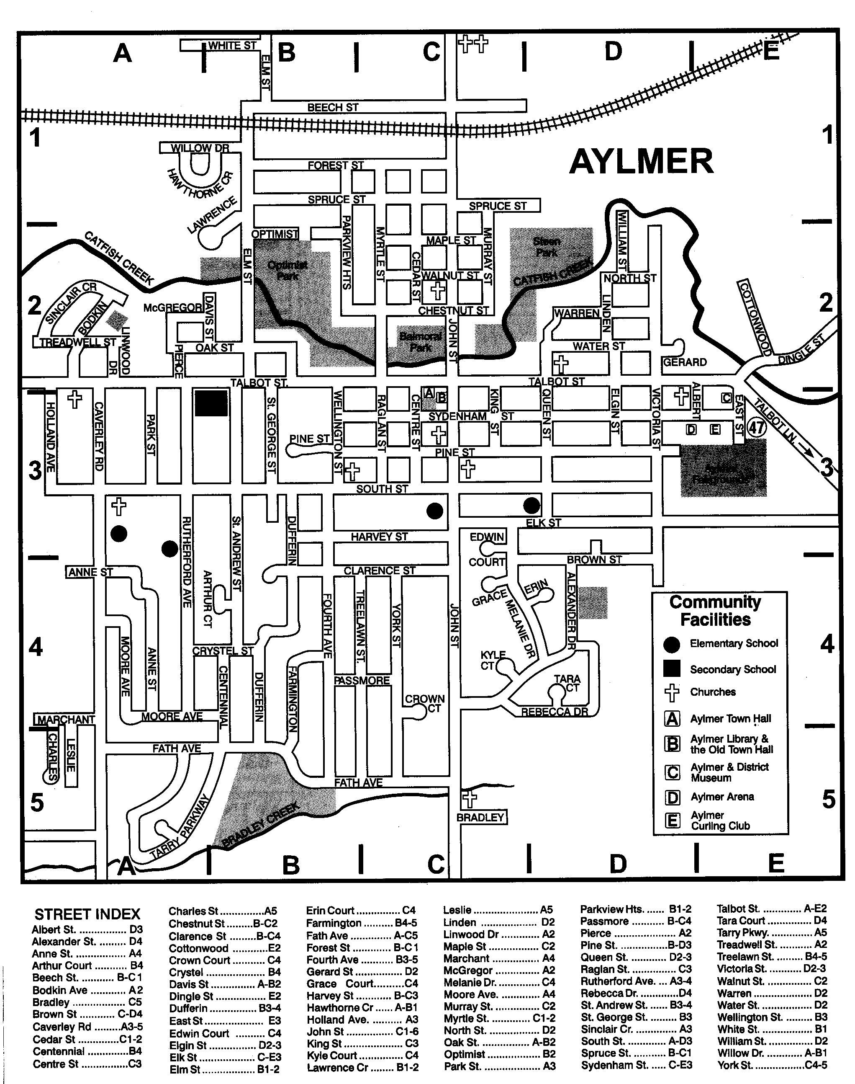

- How many churches are there in this town? _____________________
- What is the name of the street where the high school (secondary school) is found? _________________________________________________________________________

- What is the name of one of the creeks in town? _________________________________________________________________________

- What street are the Arena and the Curling Club on? _________________________________________________________________________

- Give directions from the high school to Hawthorn Crescent. ____________________________________________________________________________________________________________________________________________________________________________________________________________________________________________________________________________________________________

Post self-assessment

I think my skills have improved as a result of completing this activity.
- Yes
- No

Learner comments:
______________________________________________________________________________
______________________________________________________________________________
______________________________________________________________________________

Assessment
Task-Based Activity: Interpret a small town map
Learner Name: ___________________________ Date: ____________________________

Practitioner Name: _______________________________________

Performance Descriptors | Needs Work | Improving | Excellent
A2.2: Interpret simple documents to locate and connect information
- performs limited searches using one or two search criteria
- extracts information from tables and forms
- locates information in simple graphs and maps
- uses layout to locate information
- makes connections between parts of documents
- makes low-level inferences
- begins to identify sources and evaluate information

The learner needs to work on the following:

This task was successfully completed ______ This task needs to be tried again ______

Practitioner Comments:

Learner Comments:

