Task-Based Activity: Magazine Table of Contents
Laubach Connection: Laubach Way to Reading (LWR) Book 4, Lesson 8
OALCF Link
Relevant Goal Paths
Independence, Postsecondary, Secondary School Credit
Rationale: Learners on the Independence, Postsecondary and Secondary School Credit Paths will need to read a table of contents for a variety of different reasons.

Task-Based Activity Description: The learner will interpret a somewhat complex document (table of contents) to connect, evaluate and integrate information (A2.3).
Competency, Task Group and Level Indicators
(See Assessment page for performance descriptors)
A: Find and Use Information
A2: Interpret documents
- A2.3Interpret somewhat complex documents to connect, evaluate and integrate information

Materials Required
- Pen or pencil and eraser
- Question sheets

Overview
Activity Introduction
In lesson eight, a table of contents document is introduced. This task uses amore complex table of contents from a magazine. The learner will examine the table of contents and use sub-headings, titles, colour and images to connect information. The learner will then answer the questions.

New words
Determine any new words that you think are being introduced in the activity and review those words with the learner.

Instructions
- Have the learner fill in their name and the date.
- Have the learner complete the pre self-assessment.
- Have the learner complete the task-based activity.
- After completing the activity, have the learner complete the post self-assessment.
- After the learner has completed the task-based activity, complete the assessment section and review the results with the learner.

Extension activities
- Have learners use different tables of contents to locate articles in magazines they are interested in.
- Have learners read magazine articles and pick out words and ideas they don’t understand. Look up the meanings of the words and discuss the ideas.

Task-Based Activity: Magazine Table of Contents

Learner Name: ____________________________ Date: ____________________________

Pre self-assessment

I need to improve my skills at understanding information in tables format:
- Yes
- No

25
28
30
35
38
40
43
50
46
IN EVERY ISSUE
12 The Agenda
15 Editor’s Note
20 Your Ideas

64

58
Canadian Life
Contents
Volume 56, Issue 08
Home

Love Your Home
Five ways to fall back in love with your home.

Lush Balcony
How to turn your balcony into a chic garden.

Personal Touches
Do it yourself decoration ideas.

Health

Feel Like a Kid
Ten ways to re-energize.

8-Minute Workout
Tone your legs, core and arms with this easy routine.

Try it Tonight: Fitness Trend
The health benefits of running in the morning.

Life

Reading List
Good reads about Europe.

Career Coach
Three stress-beating strategies.

Food

Fresh & Quick
Seven weeknight suppers.

BBQ Delicacies
A savory BBQ menu that comes together in just one hour.

A Guide to Dinner Parties
An essential guide for throwing fantastic dinner parties!
Activity

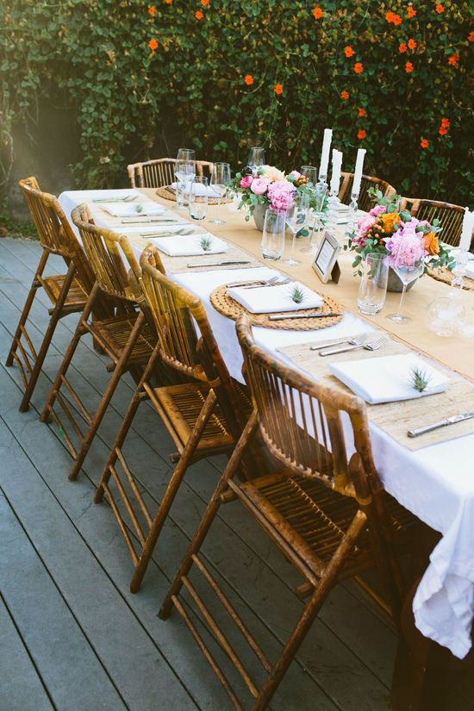


25
64
40
43
- What is the name of this magazine? ________________________________________________________________________

- What is the volume and issue of this magazine? ________________________________________________________________________

- What is in every issue of the magazine? ________________________________________________________________________

- What is the name of the article that the picture labeled with the number 64 is referring to? ________________________________________________________________________

- On what page would you find the section “8-Minute Workout”? ________________________

- What is the most interesting article on the table of contents in your opinion? Explain why? ________________________________________________________________________________________________________________________________________________________________________________________________________________________

Post self-assessment

I think my skills have improved as a result of completing this activity.
- Yes
- No

Learner comments:
______________________________________________________________________________
______________________________________________________________________________
______________________________________________________________________________

Assessment
Task-Based Activity: Magazine Table of Contents
Learner Name: ___________________________ Date: ____________________________

Practitioner Name: _______________________________________

Performance Descriptors | Needs Work | Improving | Excellent
A2.3: Interpret somewhat complex documents to connect, evaluate and integrate information
- performs complex searches using multiple search criteria
- manages unfamiliar elements (e.g. vocabulary, context, topic) to complete tasks-integrates several pieces of information from documents
- compares or contrasts information between two or more documents
- uses layout to locate information
- identifies the purpose and relevance of documents
- makes inferences and draws conclusions from information displays
- identifies sources, evaluates and integrates information

The learner needs to work on the following:

This task was successfully completed ______ This task needs to be tried again ______

Practitioner Comments:

Learner Comments:

