Task-Based Activity: Childcare Form
Laubach Connection: Laubach Way to Reading (LWR) Book 4, Lesson 6
OALCF Link
Relevant Goal Paths
Apprenticeship, Employment, Independence, Postsecondary
Rationale: Learners on the Apprenticeship, Employment, Independence and Postsecondary Paths will need to fill in forms for a variety of different reasons.

Task-Based Activity Description: The learner will read a text (situation) to connect ideas and information (A1.2). Next, the learner will use a layout to determine where to make entries and will fill out the form with the information from the situation they read (B3.2).
Competency, Task Group and Level Indicators
(See Assessment page for performance descriptors)
A: Find and Use Information
A1: Read continuous text
- A1.2:Read texts to locate and connect ideas and information
B: Communicate Ideas and Information
B3: Complete and create documents
- B3.2a: Use layout to determine where to make entries in simple documents

Materials Required
- Pen or pencil and eraser
- Question sheets

Overview
Activity Introduction
This task uses a two-paragraph situation and a blank childcare form. The learner will begin by reading the situation about Tom and Sammy. Then, they will use the information from the situation to fill out the childcare form. Have the learner re-read the situation at least once; the majority of information for the form does not appear in chronological order.

New words
Determine any new words that you think are being introduced in the activity and review those words with the learner.

Instructions
- Have the learner fill in their name and the date.
- Have the learner complete the pre self-assessment.
- Have the learner complete the task-based activity.
- After completing the activity, have the learner complete the post self-assessment.
- After the learner has completed the task-based activity, complete the assessment section and review the results with the learner.

Extension activities
- If the learner has a child, have him/her fill out the form using their own information
- Research the cost of various daycare options

Task-Based Activity: Childcare Form

Learner Name: _____________________________ Date: ____________________________

Pre self-assessment

I need to improve my skills at reading texts and filling in forms:
- Yes
- No

Activity

Read the following situation to fill out the form below, using the information you read.
Tom is going back to school. He has a three-year-old son named Sammy Fisher who was born on June 10, 2009. Tom is a single dad and cannot take care of his son all day because he wants to complete his high school diploma. Therefore, he looks for day care options. Tom is worried because Sammy has many needs. Sammy is a picky eater. He loves cheese, crackers and fruit but dislikes yogurt and muffins. Sammy loves playing with small building blocks to make castles. He is usually a happy kid but when he gets angry he throws a fit and cries loudly. Tom disciplines Sammy by placing him in a timeout area. Sammy has been to childcare before and it took about a week for him to adjust. Sammy is a fearless kid who can get into messes but he loves naptime. Tom wants to make sure that Sammy is getting an hour of sleep each afternoon and that he is able to have his stuffed robot during naptime.
Tom is also concerned about the care Sammy will get with his health issues. Sammy has occasional upset stomach, and he has asthma. Tom also has asthma and carries around both his and Sammy’s puffers. Sammy also gets frequent sore throats. Luckily, Sammy has never had any other illnesses or any developmental disorders. However, he has been hospitalized when he fractured his arm falling down the front steps of their apartment building. The last time he had a physical exam was January 25, 2014. The last time he had a visit with the dentist was December 5, 2013. Finally, the last time his eyes and ears were checked was May 14, 2014.
Tom expects the childcare centre to meet all of Sammy’s daily and medical needs. He also wants Sammy to be having fun all day.
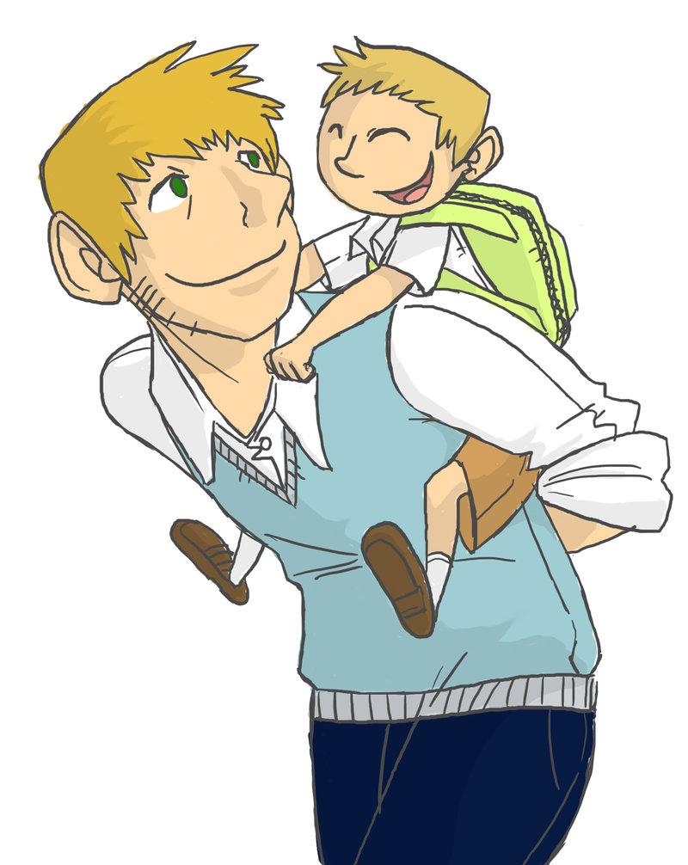

1. What FOODS does your child especially like? ________________________________________________________________
2. Especially DISLIKE? _____________________________________________________________________________________
3. Favorite toys, games, activities? __________________________________________________________________________
4. Is your child TOILET TRAINED? ______ What words does your child use for toilet? __________________________________
5. How does your child express ANGER or frustration? __________________________________________________________
6. Does your child have any special FEARS? ___________________________________________________________________
Explain ______________________________________________________________________________________________
7. When your child is upset, what helps to COMFORT him/her? ___________________________________________________
8. How do you DISCIPLINE your child? ________________________________________________________________________
9. Has your child been taking an afternoon NAP? ___________________ If so, how long? _______________________
If not, why? ___________________________________________________________________________________________
10 .Special toy or blanket for NAP? __________________________________________________________________________
11. Special FAMILY situations? ( such as custody specifications, problems arising from situations, etc.)
______________________________________________________________________________________________________
_______________________________________________________________________________________________________
12. Anticipated ADJUSTMENT problems? _____________________________________________________________________
_______________________________________________________________________________________________________
13. Any disorders/developmental (slow, advanced) diagnosed or suspected? ________________________________________
_______________________________________________________________________________________________________
14. Previous childcare child has attended: ______________________________________________________
15. Any problems at previous daycares? _______________________________________________________
16. EXPECTATIONS of Day Care Home _____________________________________________________________________
_______________________________________________________________________________________________________
17. Other COMMENTS?
____________________________________________________________________________________________________________________________________________
____________________________________________________________________________________________________________________________________________
____________________________________________________________________________________________________________________________________________

About Your Child

Health History
- Child’s name ____________________________________ Birthdate ______________________________
- Last Physical Examination ______________________________________________
3. Illnesses: (please circle)
Does your child have any problems with any of these? | Has your child had any of these diseases?
Constipation | Asthma
Convulsions | Bronchitis
Diarrhea | Chicken Pox
Fainting Spells | Diabetes
Frequent Colds | Heart Disease
Frequent Ear Infections | Hepatitis
Frequent Sore Throats | Impetigo
Lice | Measles
Ringworm | Mumps
Skin Rash | German Measles
Soiling | Polio
Stomach Upsets | Scarlet Fever
Urinary Problem | Tuberculosis
Worms | Whooping Cough
Other ILLNESSES? (besides above) ____________________________________________________________
- Has your child been HOSPITALIZED? (explain) ________________________________________________
- Has your child had INJURIES with fractures or loss of consciousness? (explain)
__________________________________________________________________
__________________________________________________________________
- Last VISION Test Date ___________________Last HEARING Test Date _________
- Last DENTIST Visit Date ___________________________
- Any other members of your family history of: ASTHMA ____DIABETES ____ EPILEPSY____

Post self-assessment

I think my skills have improved as a result of completing this activity.
- Yes
- No

Learner comments:
______________________________________________________________________________
______________________________________________________________________________
______________________________________________________________________________

Assessment
Task-Based Activity: Childcare Form
Learner Name: ___________________________ Date: ____________________________

Practitioner Name: _______________________________________

Performance Descriptors | Needs Work | Improving | Excellent
A1.2: Read texts to locate and connect ideas and information
- scans text to locate information
- locates multiple pieces of information in simple texts
- makes low-level inferences
- makes connections between sentences and between paragraphs in a single text
- reads more complex texts to locate a single piece of information
- follows the main events of descriptive, narrative and informational texts
- obtains information from detailed reading
- begins to identify sources and evaluate information

B3.2a: Use layout to determine where to make entries in simple documents
- uses layout to determine where to make entries
- begins to make some inferences to decide what information is needed, where and how to enter the information
- makes entries using a limited range of vocabulary follows instructions on documents

The learner needs to work on the following:

This task was successfully completed ______ This task needs to be tried again ______

Practitioner Comments:

Learner Comments:

