Task-Based Activity: Interpret a City Garbage Collection Flyer
Laubach Connection: Laubach Way to Reading (LWR) Book 4, Lesson 5
OALCF Link
Relevant Goal Paths
Employment, Independence
Rationale: Learners on the Employment and Independence Paths will need to read flyers for a variety of different reasons.

Task-Based Activity Description:The learner will read a somewhat complex document (flyer) to connect, find and integrate information (A2.3).
Competency, Task Group and Level Indicators
(See Assessment page for performance descriptors)
A: Find and Use Information
A2: Interpret documents
- A2.3 Interpret somewhat complex documents to connect, evaluate, and integrate information
Materials Required
- Pen or pencil and eraser
- Question sheets

Overview
Activity Introduction
In lesson five you are introduced to Lewis Burns who works for the public works department of the city. This task uses a flyer sent out from the city explaining the waste collection protocol for the upcoming year. The learner will read the flyer and locate specific pieces of information about the local garbage collection program. They will use that information to answer questions.

New words
Determine any new words that you think are being introduced in the activity and review those words with the learner.

Instructions
- Have the learner fill in their name and the date.
- Have the learner complete the pre self-assessment.
- Have the learner complete the task-based activity.
- After completing the activity, have the learner complete the post self-assessment.
- After the learner has completed the task-based activity, complete the assessment section and review the results with the learner.

Extension activities
- Have learners analyze other types of flyers such as a garage sale or a community music concert
- Have learners create a flyer

Task-Based Activity: Interpret a City Garbage Collection Flyer

Learner Name: _____________________________ Date: ________________________

Pre self-assessment

I need to improve my skills at interpreting information from flyers.
- Yes
- No

Activity

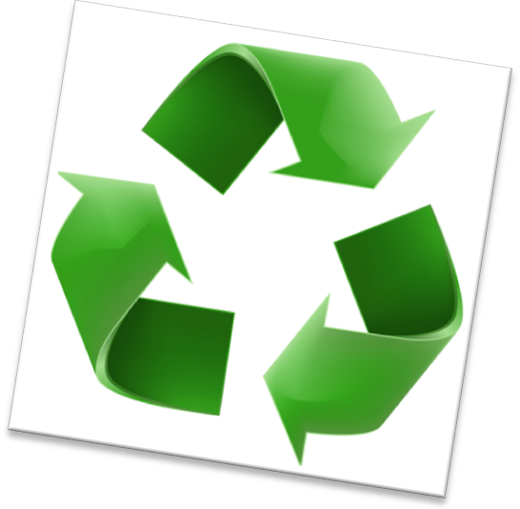
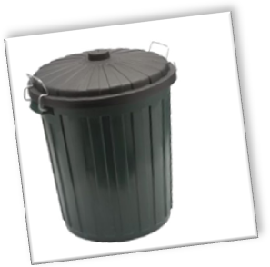
City Garbage Collection
Garbage Collection: (555) 477-8989
Recycling Collection: (555) 446-9999
Bulk Pick-up: (555) 445- 8822

Yard Waste Collection
Spring/Summer Collection,
April 3 – September 27

Fall Collection,
September 29 – November 28
Plastic bags are not accepted for city yard waste collection.
Need a bulk material pick-up?
For bulk materials (mattresses, couches, etc.) to be collected please call 555-445- 8822 to arrange a pick-up date.
Weekly Garbage Pick-up
Acceptable items for pick-up:
Plastic tubs and lids
All plastic bottles with twist off caps
Paper, milk and juice cartons
Cardboard
Metal cans, aluminum foil, glass bottles and jars
Newspapers and magazines
A maximum of six containers or bags will be collected each week. Each container or bag must weigh less than 22 kg to be collected. Please place garbage on the curb by 7:30 a.m. every Thursday.

- If you wanted to ask a question about garbage collection, which telephone number would you call? _________________________________________

- What day and what time should you bring your garbage to the curb?

_______________________________________________________________________

- What is the maximum number of bags or containers allowed on garbage collection day? _____________________

- When does the fall yard waste collection take place?

________________________________________________________________________

- What does the city not accept for yard waste collection?

_______________________________________________________________________

- How would you get bulk materials picked up from your house?

_______________________________________________________________________

________________________________________________________________________

Post self-assessment

I think my skills have improved as a result of completing this activity.
- Yes
- No

Learner comments:
______________________________________________________________________________
______________________________________________________________________________
______________________________________________________________________________

Assessment
Task-Based Activity: City Garbage Collection
Learner Name: ____________________________ Date: ________________________

Practitioner Name: _______________________________________
Performance Descriptors | Needs Work | Improving | Excellent
A2.3: Interpret somewhat complex documents to connect, evaluate and integrate information
- performs complex searches using multiple search criteria
- manages unfamiliar elements (e.g. vocabulary, context, topic) to complete tasks-integrates several pieces of information from documents
- uses layout to locate information
- identifies the purpose and relevance of documents

- makes inferences and draws conclusions from information displays
- identifies sources, evaluates and integrates information

The learner needs to work on the following:

This task was successfully completed ____ This task needs to be tried again ___

Practitioner Comments:

Learner Comments:

