Task-Based Activity: Understanding voting procedures
Laubach Connection:Laubach Way to Reading (LWR) Book 4, Lesson 18
OALCF Link
Relevant Goal Paths
Apprenticeship, Employment, Independence, Postsecondary, Secondary School Credit
Rationale: Learners on the all the goal paths will need to read information and perform web-based searches for a variety of different reasons.

Task-Based Activity Description: The learner will read a brief text (about voting) to locate and connect ideas and information and search for related information in a website.
Competency, Task Group and Level Indicators
(See Assessment page for performance descriptors)
A: Find and Use Information
A1: Read continuous text
- A1.2: Read text to locate and connect ideas and information

D: Use Digital Technology
- D.2: Perform well-defined, multi-step digital tasks

D: Use Digital Technology
Materials Required
- Pen or pencil and eraser
- Internet access
- Question sheets

Overview
Activity Introduction
This task uses an excerpt of text from a website about voting in a federal election.

In lesson eighteen, a voter registration card is filled out. Discuss with the learner if they usually vote in elections. Discuss the importance of voting to make sure opinions and beliefs of the population are represented by the government. Discuss the different levels of government and the fact that there are elections at each level. Explain that this activity is focused on information about federal elections.

New words
Determine any new words that you think are being introduced in the activity and review those words with the learner.

Instructions
- Have the learner fill in their name and the date.
- Have the learner complete the pre self-assessment.
- Have the learner complete the task-based activity.
- After completing the activity, have the learner complete the post self-assessment.
- After the learner has completed the task-based activity, complete the assessment section and review the results with the learner.

Extension activities
- In a classroom or small group setting have the learners campaign to be “leader” or “president”
- Hold a mock election

Task-Based Activity: Understanding voting procedures

Learner Name: ___________________________ Date: ____________________________

Pre self-assessment

I need to improve my skills at reading and understanding information:
- Yes
- No

Activity

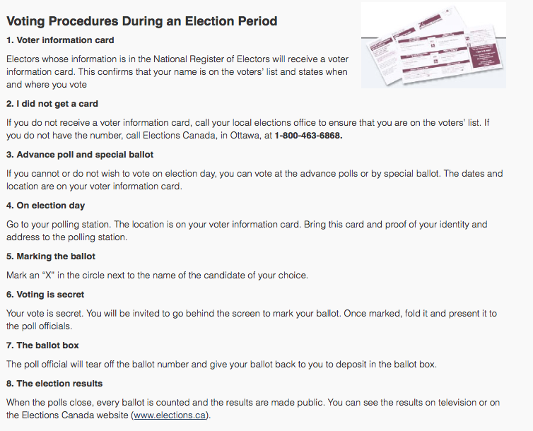

Source: http://www.elections.ca

- If you do not receive a voter information card, what should you do?

________________________________________________________________________

________________________________________________________________________

- Circle, underline, or highlight the items you need to bring with you to the polling station on Election Day.

- After you have marked your ballot, what should you do with it?

________________________________________________________________________

________________________________________________________________________

- Search for the Elections Canada website on the Internet. Use your postal code to find your electoral district. Record it here:

________________________________________________________________________

Post self-assessment

I think my skills have improved as a result of completing this activity.
- Yes
- No

Learner comments:
______________________________________________________________________________
______________________________________________________________________________
______________________________________________________________________________

Assessment
Task-Based Activity: Understanding voting procedures
Learner Name: ___________________________ Date: ____________________________

Practitioner Name: _______________________________________

Performance Descriptors | Needs Work | Improving | Excellent
A1.2: Read texts to locate and connect ideas and information
- scans text to locate information
- locates multiple pieces of information in simple texts
- makes low-level inferences
- makes connections between sentences and between paragraphs in a single text
- reads more complex texts to locate a single piece of information
- follows the main events of descriptive, narrative and informational texts
- obtains information from detailed reading
- begins to identify sources and evaluate information

D.2: Perform well-defined, multi-step digital tasks
- selects and follows appropriate steps to complete tasks
- locates and recognizes functions and commands
- makes low-level inferences to interpret icons and text
- begins to identify sources and evaluate information
- performs simple searches using keywords (e.g. internet, software help menu)

The learner needs to work on the following:

This task was successfully completed ______ This task needs to be tried again ______

Practitioner Comments:

Learner Comments:

