Task-Based Activity: Find locations on a map
Laubach Connection: Laubach Way to Reading (LWR) Book 1, Lesson 9
OALCF Link
Relevant Goal Paths
Employment, Independence
Rationale: Learners on the Employment and Independence Paths will need to read labels for a variety of different reasons.
Task-Based Activity Description: The learner will read a simple document (street map from the internet) to locate and connect information.
OALCF Competency, Task Group and Level Indicator
(See Assessment page for performance descriptors)
A: Find and Use Information
A2: Interpret documents
- A2.2 Interpret simple documents to locate and connect information
Materials Required
- Pen or pencil and eraser
- Questions sheet with map (Note: Activity will work better if printed in colour).

Overview
Activity Introduction
This task-based activity uses a Google map from the Internet that includes “York Street”. In Lesson 9 the learner is introduced to Uncle Ted’s Pet Shop. Discuss with the learner if they have ever read a city map before to locate a store. Discuss if the learner has ever looked at Google maps online. Ask the learner if they have ever had any trouble reading a map before.

New words
Review the new words that are being introduced. Explain the meanings of the words to the learner. Not all new words are in the new word list. You may need to review additional words as the learner works though the activity.

Instructions
Have the learner fill in their name and the date. Have the learner complete the pre self-assessment. Review the map with the learner. Explain that the yellow and white lines represent streets, the green spaces represent parks, and the blue represents water. Have the learner find the various locations requested on the map. To make activity more authentic search for a map of London, Ontario online and use the same section of the map for the learner to complete the activity. Adjust the descriptors as necessary. After the learner has completed the task-based activity complete the assessment section and review the results with the learner.

Extension activities
- Use a local street map to locate stores and the literacy agency.
- Search for your local area on Google maps and locate places relevant to the learner.
- Have the learner give verbal directions between two locations on the map.

Task-Based Activity: Find locations on a map

Learner Name: ________________________________________ Date: ____________________________

Pre self-assessment

I need to improve my skills at reading maps:
- Yes
- No

 | New Words
located  circle  corner | star  map  mark | park  walk

Ted’s Pet Shop is located at 3574 York Street.

- Find York Street on the map.

- The pet shop is located at the corner of Wellington Street and York Street. Mark the corner of Wellington Street and York Street with a star.

- Ted has a dog. He likes to walk his dog at Belvedere Park. Circle Belvedere Park on the map.

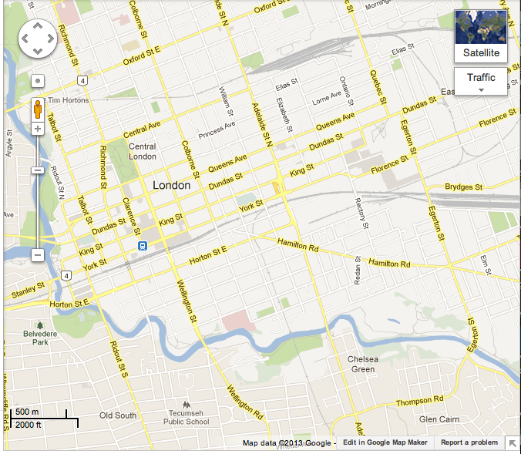

Post self-assessment

I think my skills have improved as a result of completing this activity.
- Yes
- No

Learner comments:
_________________________________________________________________________________________________
_________________________________________________________________________________________________
_________________________________________________________________________________________________

Assessment
Task-Based Activity: Find locations on a map
Learner Name: ________________________________________ Date: ____________________________

Practitioner Name: _______________________________________

Performance Descriptors | Needs Work | Improving | Excellent
A2:
- performs limited searches using one or two search criteria

- locates information in simple graphs and maps

- uses layout to locate information

- makes connections between parts of documents

The learner needs to work on the following:

This task was successfully completed ______ This task needs to be tried again ______

Practitioner Comments:

Learner Comments:

