Task-Based Activity: Read a dog tag
Laubach Connection: Laubach Way to Reading (LWR) Book 1, Lesson 8
OALCF Link
Relevant Goal Paths
Independence
Rationale: Learners on the Independence Path may need to read a tag on a pet.
Task-Based Activity Description: The learner will interpret a very simple document (dog tag) to locate specific details.
OALCF Competency, Task Group and Level Indicator
(See Assessment page for performance descriptors)
A: Find and Use Information
A2: Interpret documents
- A2.1 Interpret very simple documents to locate specific details
B: Communicate Ideas and Information
B1: Interact with others
- B1.1 Participate in brief interactions to exchange information with one other person
Materials Required
- Pen or pencil and eraser
- Questions sheet with dog tag

Overview
Activity Introduction
This task-based activity uses a dog tag. In Lesson 8 the learner is introduced to a “pup”. Discuss with the learner that pup is a short form of the word puppy. Ask the learner if they have ever had a pet dog or found a lost dog. Discuss why dogs have to be licensed and wear dog tags. Explain that a dog tag is a type of simple document that we have to interpret.

New words
Review the new words that are being introduced. Explain the meanings of the words to the learner. Not all new words are in the new word list. You may need to review additional words as the learner works though the activity.

Instructions
Have the learner fill in their name and the date. Have the learner complete the pre self-assessment. Have the learner review the dog tag and answer the questions that follow orally. After the learner has completed the task-based activity complete the assessment section and review the results with the learner.

Extension activities
- Create a variety of different tags for the learner to interpret.
- If the learner has a dog, ask them to copy down the information on the tag (if the dog is licensed). If the dog is not licensed do an Internet search with the learner to learn more about the requirements of licensing where they live.
- Do the same activity with a medic alert tag if you have one available.

Task-Based Activity: Read a dog tag

Learner Name: ________________________________________ Date: ____________________________

Pre self-assessment

I need to improve my skills at reading documents:
- Yes
- No

 | New Words
call  licence | lost  name | neighbourhood  please

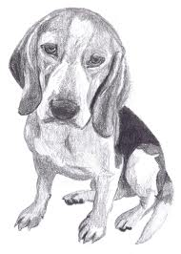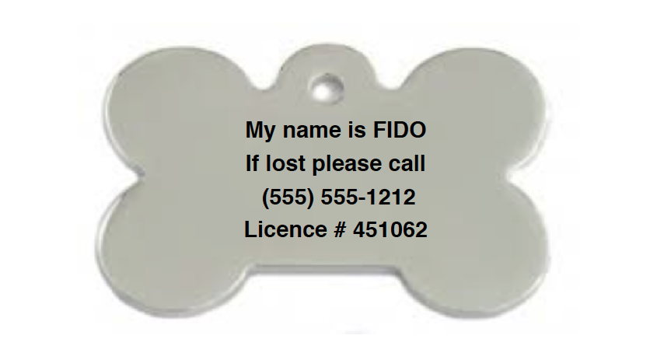

Look at the dog tag and answer the following questions orally:

- What is the dog’s name?

- If you found this dog in your neighbourhood what phone number would you call?

- What is the number of the licence?

Post self-assessment

I think my skills have improved as a result of completing this activity.
- Yes
- No

Learner comments:
_________________________________________________________________________________________________
_________________________________________________________________________________________________
_________________________________________________________________________________________________

Assessment
Task-Based Activity: Read a dog tag
Learner Name: ________________________________________ Date: ____________________________

Practitioner Name: _______________________________________

Performance Descriptors | Needs Work | Improving | Excellent
A2:
- scans to locate information

- interprets brief text and common symbols

- locates specific details in simple documents, such as labels and signs

B1:
- Participates in short simple exchanges

- Repeats questions to confirm understanding

The learner needs to work on the following:

This task was successfully completed ______ This task needs to be tried again ______

Practitioner Comments:

Learner Comments:

