Task-Based Activity: Complete a family tree
Laubach Connection: Laubach Way to Reading (LWR) Book 1, Lesson 7
OALCF Link
Relevant Goal Paths
Employment, Independence
Rationale: Learners on the Independence Path may want to create a family tree.
Task-Based Activity Description: The learner will make straightforward entries (family member names) to complete a simple document (family tree template).
OALCF Competency, Task Group and Level Indicator
(See Assessment page for performance descriptors)
B: Communicate Ideas and Information
B3. Complete and create documents
- B3.1a Make straightforward entries into very simple documents

Materials Required
- Pen or pencil and eraser
- Questions sheet with family tree template

Overview
Activity Introduction
A simple family tree template is used in this task-based activity. You can substitute with a similar template or have the learners create a family tree. In Lesson 7 a family is spending a day at the river. Discuss the relationships between the people at the river. Discuss whether the learner has ever created a family tree before. Ask the learner if they have any siblings.

New words
Review the new words that are being introduced. Explain the meanings of the words to the learner. Not all new words are in the new word list. You may need to review additional words as the learner works though the activity.

Instructions
Have the learner fill in their name and the date. Have the learner complete the pre self-assessment. Review the different sections on the family tree template with the learner. Show them where to put their name. Explain that they may not be able to fill out all of the spots; it will depend on their family. Have them complete the rest of the family tree. After the learner has completed the task-based activity complete the assessment section and review the results with the learner.

Extension activities
- Have the learner create a family tree from scratch instead of using the template provided. This could involve the task group “express oneself creatively”.

Task-Based Activity: Complete a family tree

Learner Name: ________________________________________ Date: ____________________________

Pre self-assessment

I need to improve my skills at using and understanding documents:
- Yes
- No

 | New Words
brother  sister | mother  father | grandmother  grandfather  relatives

Complete the simple family tree by filling in the names of your relatives. Start by writing your own name at the bottom in the spot that says “me”.

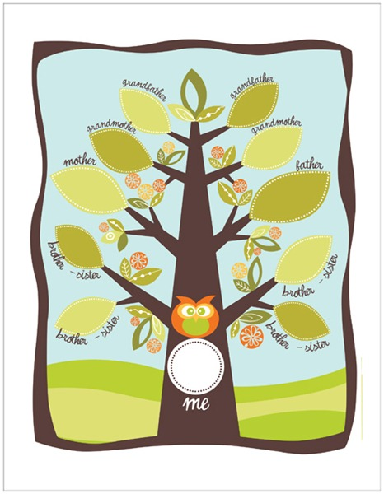

Post self-assessment

I think my skills have improved as a result of completing this activity.
- Yes
- No

Learner comments:
_________________________________________________________________________________________________
_________________________________________________________________________________________________
________________________________________________________________________________________________

Assessment
Task-Based Activity: Complete a family tree
Learner Name: ________________________________________ Date: ____________________________

Practitioner Name: _______________________________________

Performance Descriptors | Needs Work | Improving | Excellent
B3:
- makes a direct match between what is requested and what is entered

- makes entries using familiar vocabulary

The learner needs to work on the following:

This task was successfully completed ______ This task needs to be tried again ______

Practitioner Comments:

Learner Comments:

