Task-Based Activity:
Identify Poisonous Household Items
Laubach Connection: Laubach Way to Reading (LWR) Book 1, Lesson 3
OALCF Link
Relevant Goal Paths
Employment, Independence
Rationale: Learners on the Employment and Independence Paths will need to read labels for a variety of different reasons.
Task-Based Activity Description: The learner will read and complete a simple checklist (common poisonous household items).
Competency, Task Group and Level Indicator
(See Assessment page for performance descriptors)
A: Find and Use Information
A2: Interpret documents
- A2.1 Interpret very simple documents to locate specific details
B: Communicate Ideas and Information
B3. Complete and create documents
- B3.1a The learner will make straightforward entries into a very simple document

Materials Required
- Pen or pencil and eraser
- Questions sheet with checklist

Overview
Activity Introduction
This task-based activity uses a checklist for common poisonous household items.
In Lesson 3 a snake is introduced. Many people are afraid of snakes as they think they are venomous or poisonous. Discuss with the learner how likely it is that they would encounter a venomous snake. Discuss how we encounter poisonous substances every day in our own homes. Explain that in this activity they will be using a checklist, which is an example of a document. Have the learner complete the pre self-assessment.

New words
Review the new words that are being introduced. Explain the meanings of the words to the learner. Not all new words are in the new word list. You may need to review additional words as the learner works though the activity.

Instructions
Have the learner fill in their name and the date. Have the learner complete the pre self-assessment. Review the safe home checklist with the learner. Make sure they understand all of the terms used. Have them complete the safe home checklist. Encourage them to set a short-term goal of using the safe home checklist to make sure they have stored all the poisonous products in their house safely. When they have completed the activity have the learner complete the post self-assessment. After the learner has completed the task-based activity complete the assessment section and review the results with the learner.

Extension activities
- Have the learners make a brief presentation on what items they had in their home.
- Use a dictionary to define unfamiliar words on the checklist or on products that they found in their home.

Task-Based Activity: Identify Poisonous Household Items

Learner Name: ________________________________________ Date: __________________

Pre self-assessment

I need to improve my skills at reading lists:
- Yes
- No

1. Review the Safe Homes Checklist for new words. Make a list of the new words and review them with your instructor.

2. Look at the Safe Homes Checklist. Check off all of the items you keep in your house. When you go home take the list and make sure you have them stored properly!

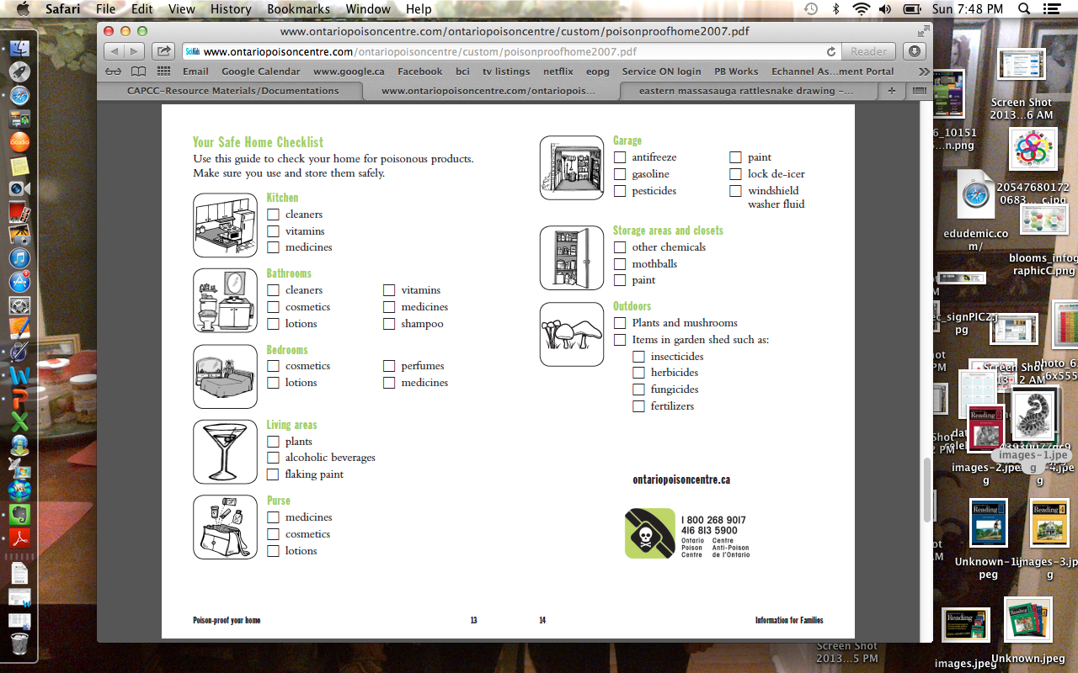

Post self-assessment

I think my skills have improved as a result of completing this activity.
- Yes
- No

Learner comments:
_________________________________________________________________________________________________________
_________________________________________________________________________________________________________
_________________________________________________________________________________________________________

Assessment
Task-Based Activity: Identify Poisonous Household Items
Learner Name: ________________________________________ Date: ___________________________

Practitioner Name: _______________________________________

Performance Descriptors | Needs Work | Improving | Excellent
A2.1:

- scans to locate specific details

- interprets brief text and common symbols

- identifies how lists are organized (e.g. sequential, chronological, alphabetical)

B3.1a:

- makes a direct match between what is requested and what is entered

- makes entries using familiar vocabulary

The learner needs to work on the following:

This task was successfully completed ______ This task needs to be tried again ______

Practitioner Comments:

Learner Comments:

